#### RECRUITING ASSISTANTS FOR HR MANAGERS

**1) INTRODUCTION**

1.1 Overview

As an HR Assistant, We will be responsible for Managing and Handling the day to day HR Activities. Recruitment Managers will work closely within our recruiters to manage sourcing, interviewing and employment process. Recruitment is the overall process of identifying, sourcing, screening, shortlisting and interviewing candidates for jobs within an organization.

1.2 Purpose

* Provide an efficient general and administrative HR support service to stop and managers.
* The role is critical in ensuring the operational support to the HR Team through supporting all manner of administrative tasks and requests related to general queries, processes, systems, policies and general HR administration, excalating enquiries where necessary.
* HR Assistant is a Professional, responsible for the daily administrative and HR duties of an organisation.
* They assist with recruitment and record maintenance for payroll processing as well as provide clerical support to all employees.
* Performs other duties as assigned.

**2) Problem Definitions & Design Thinking**

2.1 Empathy Map

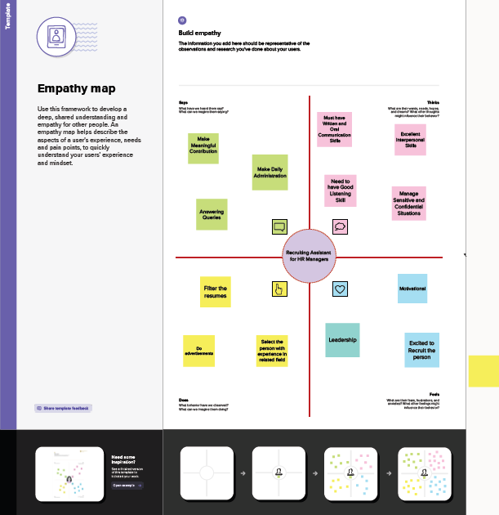

2.2 Identation & Brainstroming Map

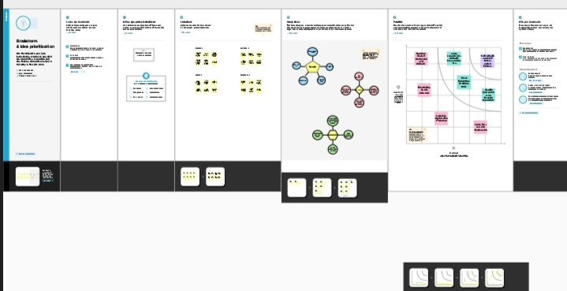

**3) RESULT**

3.1 Data Model:

|  |  |
| --- | --- |
| **Object**  **Name** | **Field in the Object** |
| **Custom** | |  |  | | --- | --- | | **Field label** | **Data type** | | Job Posting Sites | Text | | Review | Auto Number | |
| **Custom**  **Junction** | |  |  | | --- | --- | | **Field label** | **Data type** | | Job Posting | Auto Number | |

3.2 Activity & Screenshot

**Milestone: 2**

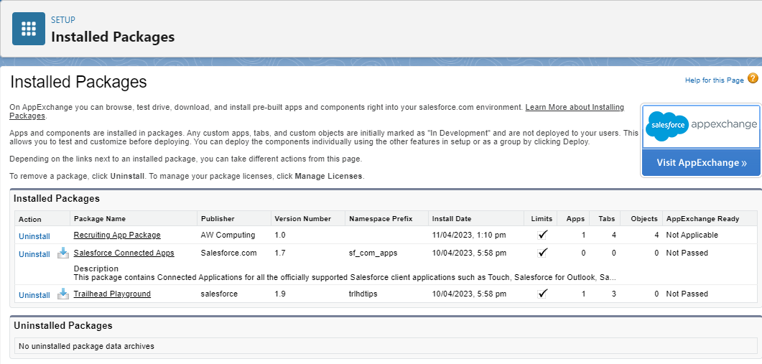

**Milestone: 7**

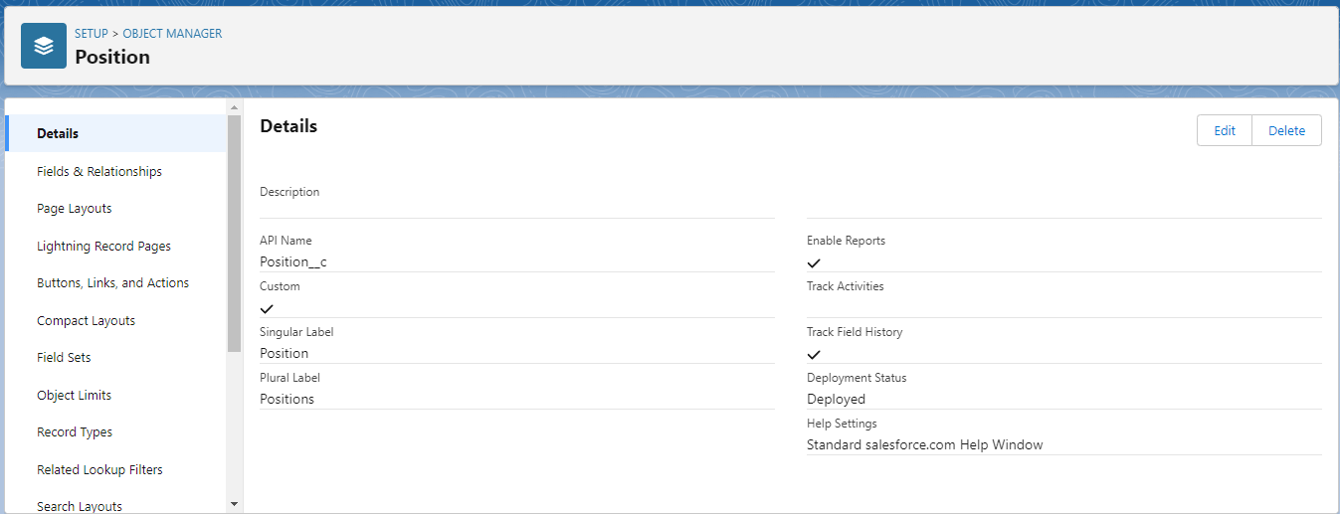

**Milestone: 9**

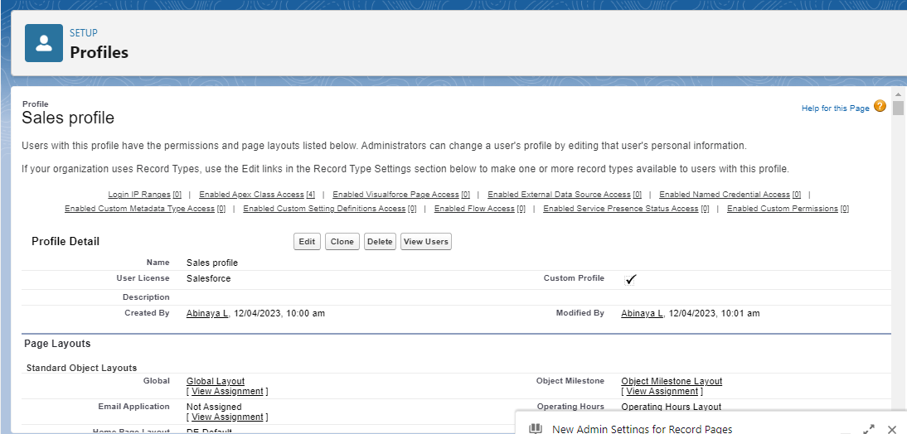

**Milestone: 11**

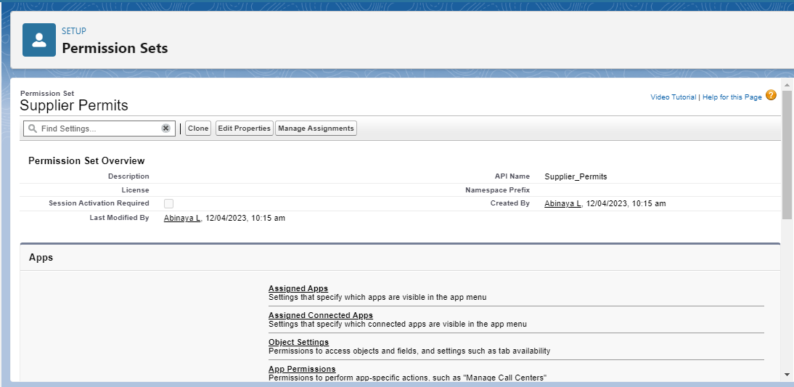

**4) Trailhead Profile Public URL**

**Team Lead –** <https://trailblazer.me/id/abinl>

**Team Member 1 –** <https://trailblazer.me/id/anups37>

**Team Member 2 –** <https://trailblazer.me/id/amubeen6>

**Team Member 3 –** <https://trailblazer.me/id/daisr1>

**5) ADVANTAGES**

* They often help manage job trainings where employees can learn transferable skills.
* Faster hiring
* Higher quality candidates
* Specialist knowledge
* They might help provide employees with performance reviews that offer valuable information about their work.

**DISADVANTAGES**

* Maintaining a safe distance
* Lack of employer branding
* Higher competition
* Lower Recognition value
* Greater experience expected

**6) APPLICATIONS**

* Coordinate hiring activities
* Undertake clerical duties
* Prepare and post job ads online
* Help with resumes screening and initial phone screen
* Greet and assist interviewers onsite
* Maintain candidate database

**7) CONCLUSION**

Include allnecessary skills and include a list of desired skills that are not necessary but that would enhancethe candidates changes. Evaluation and control is the last stage in the process of recruitment.

**8) FUTURE SCOPE**

One should remember that HR needs to adapt and be agile. HR not be replaced. MBA in Hr future scope is bright. To make the majority of the employees live the values of the organization.